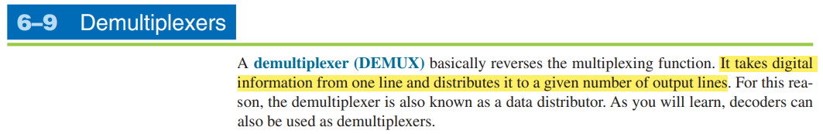

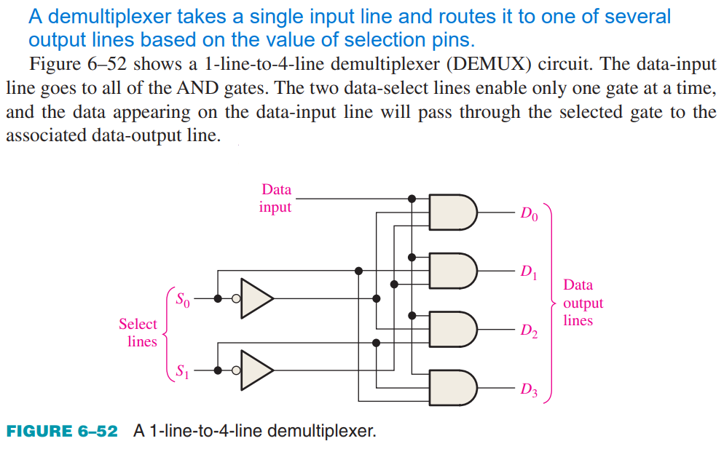

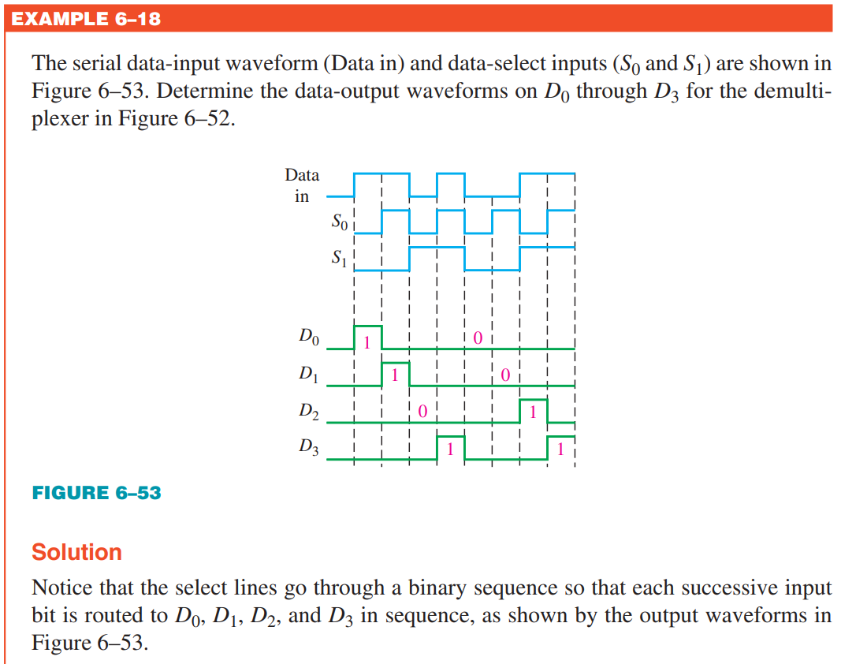

how a demultiplexer typically works:

1. **Input**: A demultiplexer has a single input line that carries the data signal to be distributed.
2. **Select Lines**: It also has one or more select lines (control lines) that determine which output line the input signal will be routed to. The number of select lines determines the number of output lines and thus the number of possible selections.
3. **Output Lines**: A demultiplexer has multiple output lines, labeled Q0, Q1, ..., Qn, where n represents the number of output lines. The input signal is routed to one of these output lines based on the values of the select lines.
4. **Selection Logic**: Inside the demultiplexer, there is selection logic that interprets the values of the select lines and routes the input signal to the corresponding output line.
5. **Output**: The input signal is forwarded to the selected output line while being inhibited from reaching the other output lines.



